Oxbow Generic Dashboard Project

## Overview

This document covers the design of the Oxbow Generic Dashboard. SharePoint provides the user with list views and CAML queries as tools to display lists, however these tools sometimes lack the flexibility required to build a centralized dashboard view of multiple lists and views. The Generic dashboard comes in the form of a web part with the goal of making it easy to display the contents of multiple lists in a consolidated interface that is intuitive and fast to navigate.

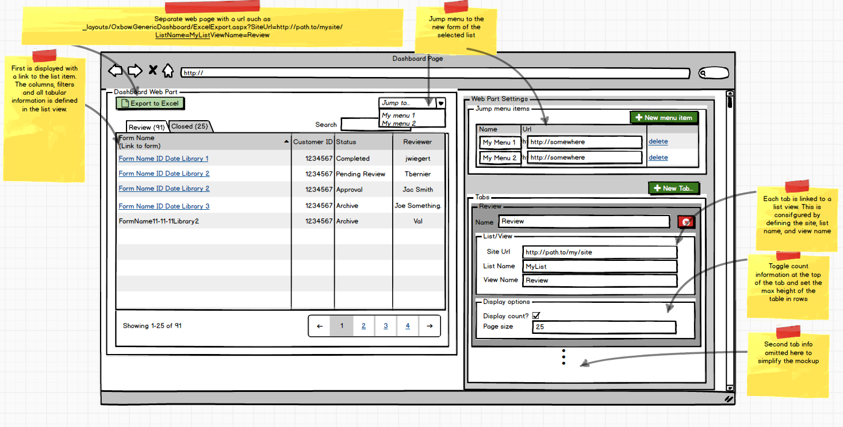

## Design

The dashboard has a tabbed interface with a table inside of each tab. Each tab is linked to a specific view of a SharePoint list and the table displays the items within the view as dictated by the view’s filtering, sorting and field order display specifications.

### Tab and Table design

The tables allow for client-side sorting on any column, and a search box that intelligently filters the contents of the table to match the substring as the user types. When a user clicks on a tab a cookie is set on the browser to remember the last selected tab between page loads. All table sorting and filtering settings are remembered between page loads. Tables are paged on the client side for fast navigation, and the page size for each table is configurable through the web part settings. Tabs can optionally display list item count at the top of the tab. The caption of each tab is configurable. The number of tabs is unlimited but too many tabs may cause a cluttered layout and slower loading experience. The first column of each table row is a hard-wired hyperlink to the list item.

### Excel Export design

A tab view can be exported to excel with the click of a button. This is built by adding an extra ASPX page in the templates folder of the solution dedicated for generating excel files. This ASPX page requires parameters such as the site url, the list name and the view name. A simple link such as the following example will return a rendered single sheet excel workbook: [http://.../_layouts/Oxbow.GenericDashboard/ExcelExport.aspx?SiteUrl=http://path.to/mysite/?ListName=MyList&ViewName=Review](http://.../_layouts/Ltcp.GenericDashboard/ExcelExport.aspx?SiteUrl=http://path.to/mysite/?ListName=MyList&ViewName=Review)

### Jump Menu Design

The drop-down list on the upper-right hand corner of the web part is designed to allow for quick customizable navigation of related pages to the dashboard. The top section of the web part properties allows you to build a set of display names and URLs that will appear in the drop down list. When the user selects an item from the list then the url will be automatically loaded in a new tab. Examples of a useful jump menu include a “new item” option with a link to a form that lets users add an item to the list in the dashboard.

